**Invalid Test Cases Results**

1. Invalid Password/Username

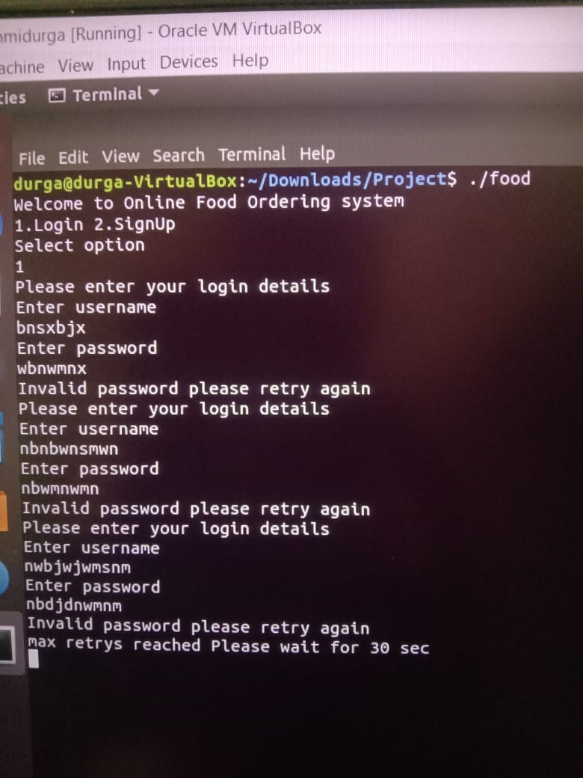

1. Entered Invalid Credentials thrice



3.Entered Invalid Location

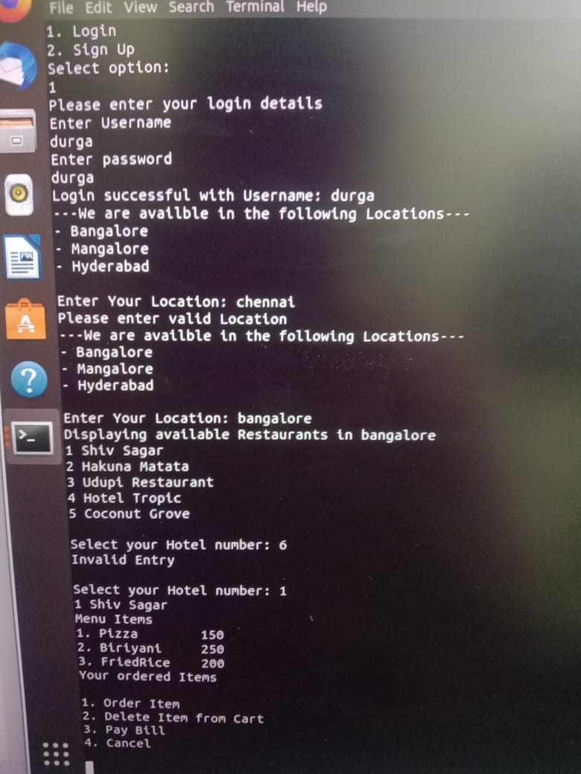

4.Enter Invalid Hotel option



5.User Transition (1.Order,2.Delete,3.PayBill,4.Cancel)If select 5

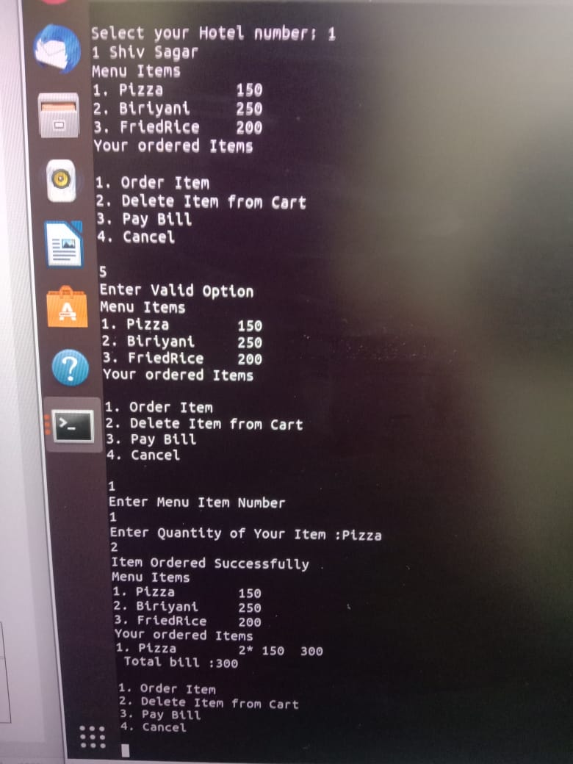

6.Enter Invalid Option for payment

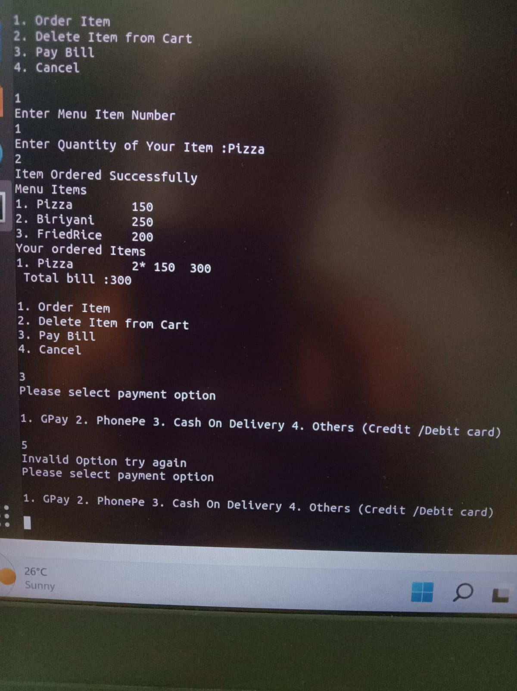

7. Enter Invalid Menu Item Number for Update

